Ben
Weekly Relays User Guide
TOPICS LEGEND
 |  | WEEKLY RELAYS |  | Sept. 22, 2016
YOUR DEPARTMENT NEWS |  |  | UTMB NEWS
IMO  IMO would like to welcome Cheryl Evans as the Course coordinator for MCT and NHB!!!  MS1 successfully completed a NBME orientation in the computer testing center this week. Special thanks to Sarah Dolezal and all the IMO staff for assisting and guiding students through the process.  The GAR midterm for MS1 went off without a hitch. Nice job Sarah Dolezal!  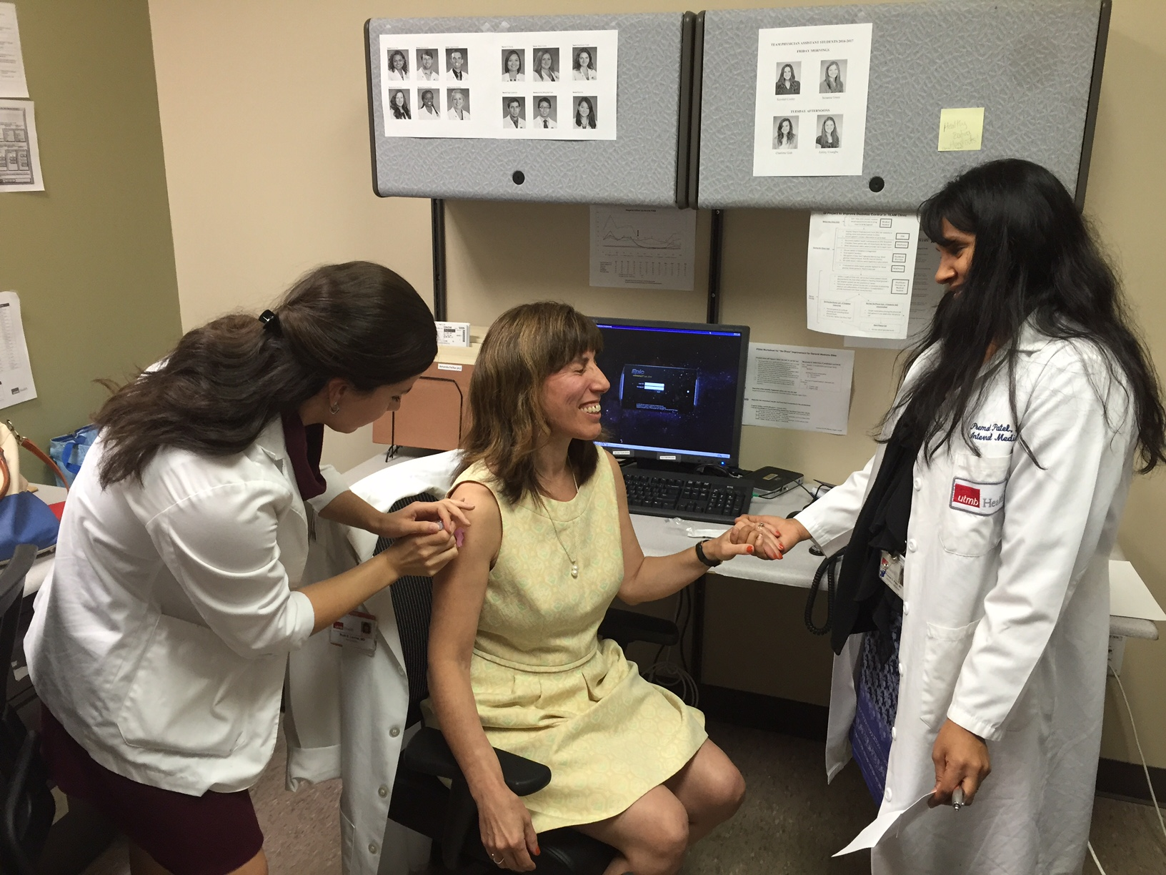  In TEAM clinic, 3rd year SCOPE student Paulo Bustillos administers flu shot to Dr. Ruth Levine while Dr. Premal Patel provides support. Don't forget to get your flu shot!! |  |  | Student enrollment increases:  Total student enrollment across all four schools increased from 3,169 in the fall of 2015 to 3,314 this fall. The largest increases came from the School of Health Professions and the School of Nursing. The total number of students enrolled at UTMB has increased by more than 36% from fall 2009 to fall 2016.  Security and safety tips:  Please routinely practice these tips to improve your personal safety and overall campus security:  - WEAR your UTMB ID badge!  - Pay attention to your surroundings. Be alert, trust your instincts, take precautions and report crimes and suspicious activities. See something, say something.  - When on the Galveston Campus, familiarize yourself with the locations of the code blue and emergency assistance phones. Emergency Phone Locations Map  - To reach UTMB Emergency Dispatch Personnel:  - For Galveston Campus, dial 9-1-1 from any campus-owned phone  - For League City Campus, dial 9-1-1 from any campus-owned phone  - Or, dial (409) 772-1111 from any mobile phone  - For emergencies on the Angleton Danbury Campus and all UTMB satellite clinics, dial 9-1-1 to reach local authorities.  - Avoid walking alone at night. Take advantage of UTMB’s Safety Watch Program, a program that provides police escort service during the hours between dusk and dawn on UTMB’s three campuses.  - Never leave your property unattended in public areas.  - And, remember, for non-emergencies or to report suspicious circumstances, call UTMB Police at (409) 772-2691.  UT System physical activity challenge—Walktober:  Fall into fitness with the 2016 UT System Physical Activity Challenge. This 31-day walking challenge begins Oct. 3 and is open to all UT SELECT medical plan members and dependents age 18 and above. Those who participate will be eligible for rewards. Sign up today at utlivingwell.com or see the flier for more details.  Best Care—Keep UTMB beautiful:  The first impression of our hospitals is the appearance and friendliness of our staff. It sends a message to our patients and other guests that UTMB is a clean and quality place to receive care. Environmental Services (EVS) would like to share a special video on how YOU can help contribute to Best Care. We need your help to maintain the cleanliness of our environment. Thank you for being a friend to EVS! https://intranet.utmb.edu/best-care/EVS/default.asp
TOPICS  LEGEND | PATIENT CARE EDUCATION & RESEARCH INSTITUTIONAL SUPPORT CMC
AROUND UTMB (Use the legend above to quickly find items of interest to your team)
UTMB NEWS (continued)  Temporary closure of the ADA tunnel from Hospital Parking Garage to John Sealy East Entrance:  Construction is currently underway to connect Jennie Sealy Hospital, Waverley Smith Pavilion and John Sealy Hospital on the Galveston Campus with one continuous public corridor. As part of this project, the ADA tunnel between the Hospital Garage and the John Sealy east entrance will be temporarily closed from Oct. 3 through mid-November. During this time, valet parking services will be available for patients and families at John Sealy Hospital (Women’s Services, Pediatrics, Burn Unit, Cath Lab and Sleep Lab). ADA patients/families who opt not to valet park may enter the Jennie Sealy Hospital from either level of the parking garage and follow the signs to John Sealy Hospital. Standard parking rates apply (there is no additional charge for the valet service over and above the standard parking fee). Valet parking services will cease when the ADA tunnel reopens. At that time, short-term parking spots will be designated in the John Sealy circle drive to be used only by patients in labor. To allow better access for patients and visitors, employees should NOT use the John Sealy circle drive for employee drop-off and pick-up.  Epic tip of the week:  Did you know that you can prioritize a diagnosis on the problem list by marking it with a high, medium or low priority? In the Problem List, click the “Unprioritized” link and select an appropriate priority. Users have the ability to sort problems by priority, either high to low or low to high. For those not familiar with medical record terminology, the problem list states the most important health problems facing a patient, such illnesses or diseases, injuries, and anything else that has affected the patient or is currently ongoing with the patient. The list also usually identifies when an injury or illness occurred or was discovered and when it was resolved. A well-designed medical problem list provides a clear picture of a patient's health problems that require consideration or medical intervention. |  |  | CMC —CID section in reports renamed ICN:  The “CID” section in reports has been renamed “ICN” and there is a new report that allows you to get a list of offenders on your units by month of incarceration. Be sure to refresh the report each time you open it by clicking “View” at the top and “Refresh.”  CMC —MRIS summaries:  There is no longer any need to email MRIS summaries to the MRIS referral group. They will now go to that group automatically.  CMC —UT System Learning Zone:  There is a new learning portal for topics that may be of interest to UTMB staff. It is the UT System Learning Zone and more details are available for this online 24/7 access professional development tool at https://hr.utmb.edu/tod/learning/.  CMC —Pharmacy customer satisfaction survey:  The annual pharmacy customer satisfaction survey is now available. It is an online survey that takes approximately 10 minutes to complete. The survey can be found by visiting  http://cmc.utmb.edu/QuickLinks/, clicking the green "Quick Links" button then "CMC Pharmacy Survey." The survey will be available until Nov. 1. Please take a few minutes to evaluate the services provided by the UTMB CMC Department of Pharmacy as it pertains to your facility. The survey is an opportunity for you to voice your opinions, ideas and concerns privately. The survey cannot be traced back to an individual, and you are encouraged to provide direct and honest responses. Your input is needed to identify areas that need improvement. Your time and feedback are sincerely appreciated.
DID YOU KNOW?
Over the past eight years, the UTMB Badge Office has issued 99,866 identification badges, 18,917 of which remain active today. The Badge Office is part of the university’s Police Department and is staffed by two full-time employees with U.S. Department of Justice background clearances. Located at police headquarters in the Rebecca Sealy Building (Galveston Campus), the Badge Office produces and issues official university ID badges to students, faculty, staff, select contractors and visitors. UTMB ID badges are the property of the university and are used as official identification; they also serve as smartcards that can provide access to designated parking lots and office suites. A critical element of our WEAR campaign, your ID Badge quickly identifies you as a member of the university community. You may reach the UTMB Badge Office at (409) 772-0657. For more information on the WEAR campaign, please visit iUTMB.

